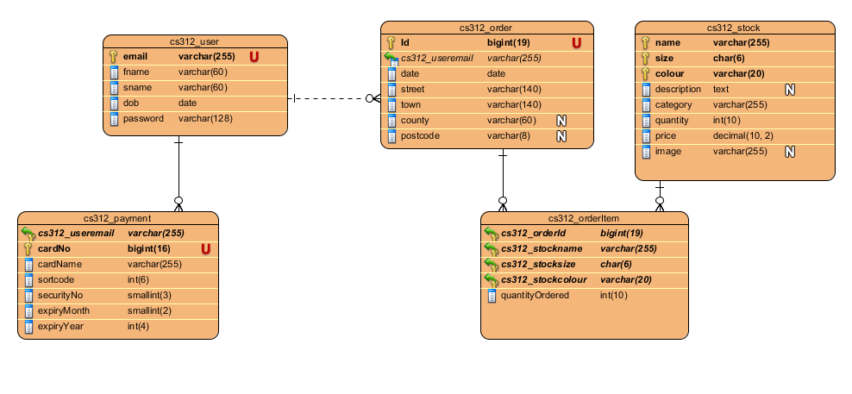
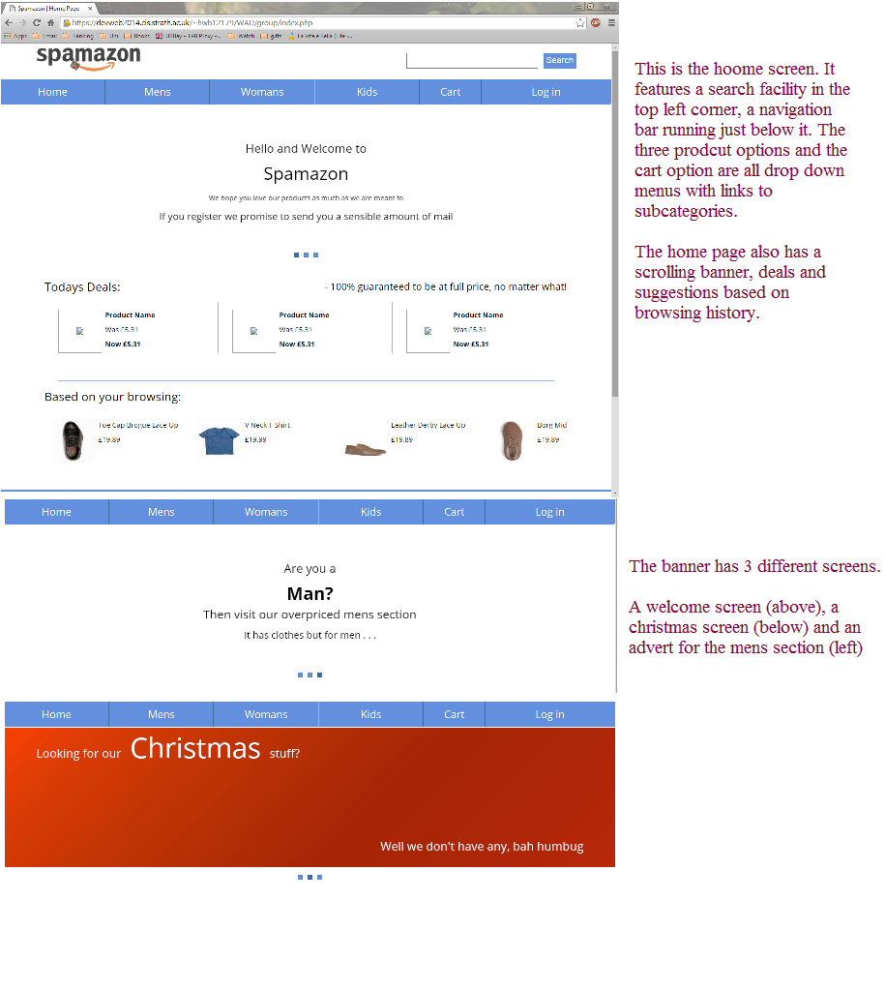
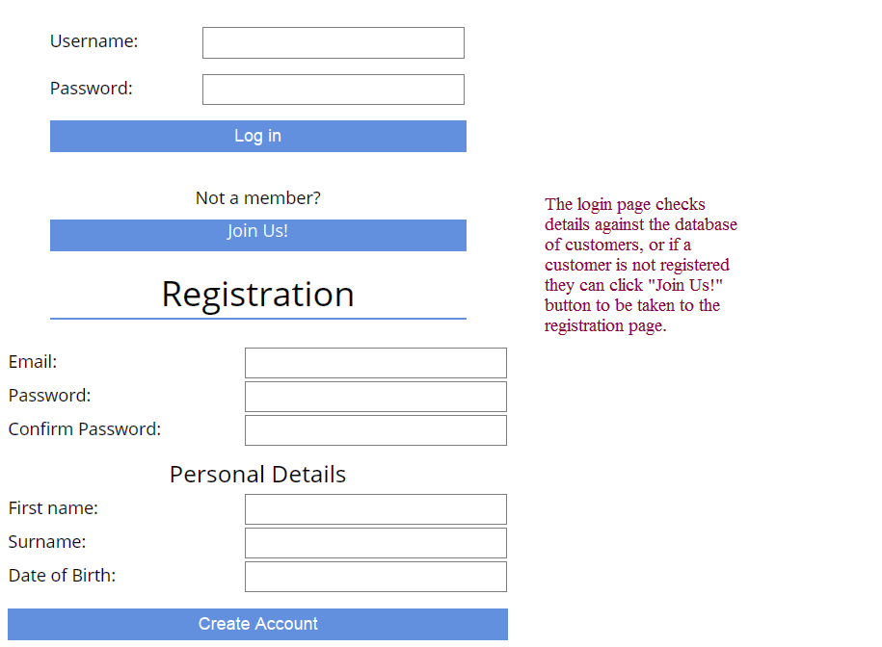
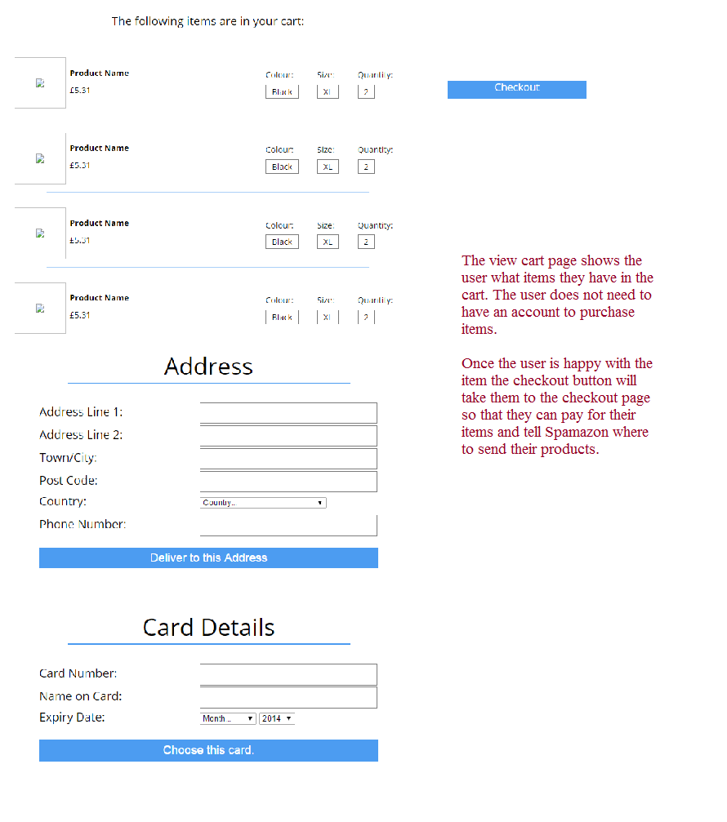
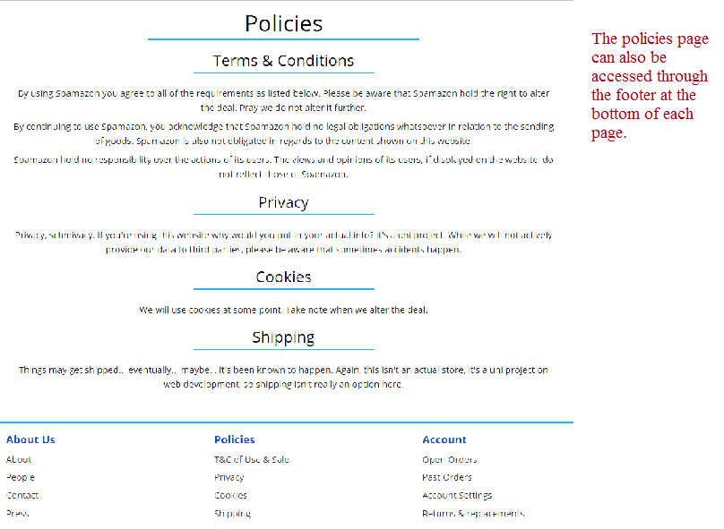
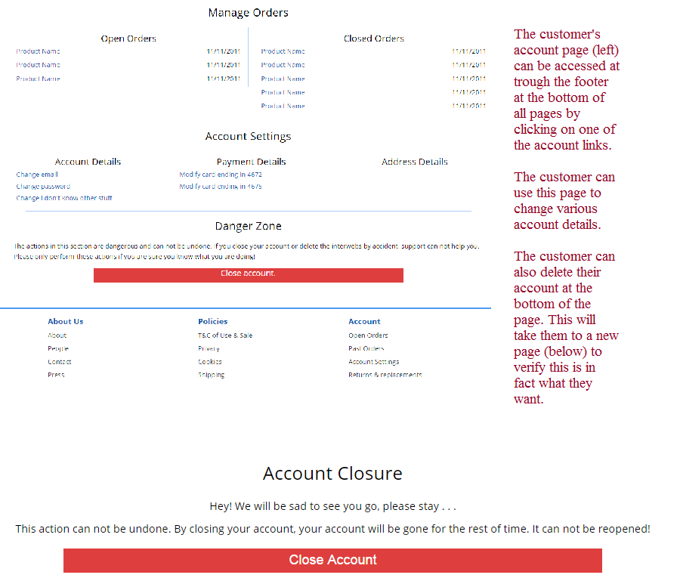
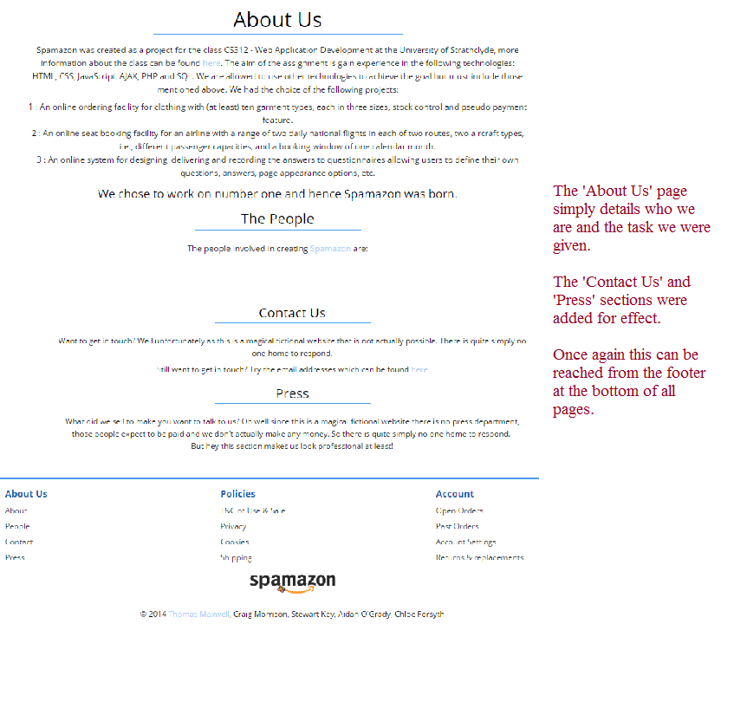
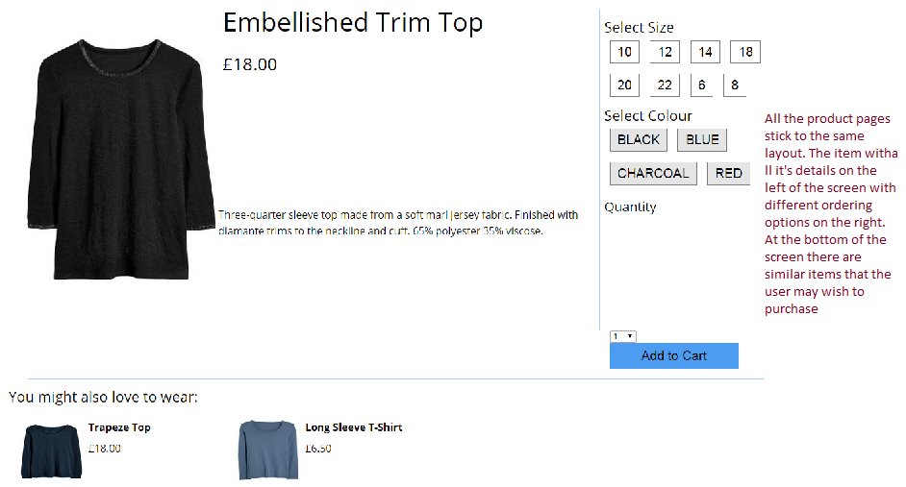
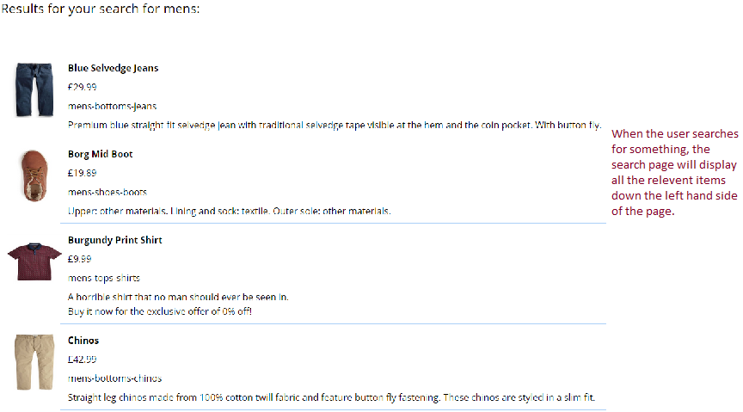
CS312
Group Project

SPAMAZON

Authors:
Chloe Forsyth xeb12185@uni.strath.ac.uk
Craig Morrison hwb12179@uni.strath.ac.uk
Stewart Key ypb12171@uni.strath.ac.uk
Thomas Maxwell gvb12181@uni.strath.ac.uk
Aidan O'Grady wlb12153@uni.strath.ac.uk

Contents:

1 | Introduction
2 | System overview
3 | Member contributions
4 | Approach
5 | General Requirements
6 | Logical Design
7 | User Interface / Physical Design
8 | Evaluation
9 | Comparison

Introduction
The group has decided to make a website called “Spamazon” using different languages such as CSS, HTML, PHP, MySQL, and JavaScript. The website will have around 6 pages and allow customers to login and purchase items.
This report will detail the various aspects of the website and also the approach taken to creating the website. The contribution of each member will be mentioned and which languages were used. To better understand the website the general requirements, the logical design (an Entity Relationship Diagram) and the physical design (annotated screen shots) have also been included. A critical evaluation of our will explain what we have achieved, what we might have done better had we had more time or tools and what we had intended on including but were unable to.

System Overview
When the customer first access the website they will be directed to the home page. From there they can view the deal and different products they might be interested. From there the customer can access all other pages. They can browser the product pages, login or have a look at the technical pages such as the policies pages or the about section.
All customer details including invoices will be stored in a back end database. Each customer will have an email and password stored in order for them to login. When the customer logs in which they can do from the navigation bar at the top of the page, they will have a specialised home page to detail their previous orders and suggest products that they may like to purchase. They will also have their card details stored to make for a faster checkout.
The products are split into three different categories: Men’s, Women’s and Children’s. It is then split up further into tops, bottoms, shoes and “other stuffs.” These are all accessible through the navigation bar at the top of the page. The product pages feature a description of each item, a picture and the price. On the right hand side there are different options for size, colour and quantity to ensure the customer orders the correct item for them.
Once the customer has decided on what they want to purchase they can view their shopping cart. Once again this is accessible from the navigation bar at the top of the screen. Once they are satisfied with their choices they can then proceed to checkout wither using the button in the cart page or from the navigation bar. If the customer does not have their address and payment information stored in their account they will be required to enter it.
If the customer wishes to view any of the company information they can click on one of the links in the footer of any page. In the footer they can also access their own account information if they wish to change any of the information stored about them or to close their account.
Member Contributions
Author | Languages Used | Breakdown of Work
Craig Morrison | MySQL  PHP | Database including Entity Relationship Diagram  Registration / date validation  Account pages  Logout page
Tom Maxwell | PHP/HTML  JavaScript  SAAS/CSS  JQuery | Front end design  Website layout  About page  Shopping Cart  Home page  Account pages  Product pages  Login / Registration Pages
Chloe Forsyth | English  CSS | Report  Helped format the Product pages
Stewart Key | JavaScript | Session information  Input Validation  Confirmation pages  Cookies
Aidan O'Grady | PHP/HTML  Various | Started the Search page  Policies pages  Practical 4

Approach
The group decided to use an object oriented design approach to the website. Object Oriented Design can be described as a design strategy where system designers think in terms of ‘things’ instead of operations or functions. With Object Oriented Design there is no real reason or rhyme to the code. Each section of code relies on an event, like a button click, from the front end by the user. The system as a whole is designed around how each part will interact with each other, how one thing will set in motion another and another like dominoes. All through the implementation, the code will be tested and debugged to make sure everything works the way it should. After this the program will be tested as a whole and provided everything works as it should it will be available online.

General Requirements
Functional Requirements:
- Have a log in facility
- Validate user logins
- Be able to store customer information in a back-end database
- Have a selection of products available in at least three sizes
- Be able to see the stock level
- Automatically replenish stock levels
- Have a shopping cart so customers can buy more than one item at a time
- Online payment feature
- Search facility
- Order history
Logical Design
User Interface / Physical Design
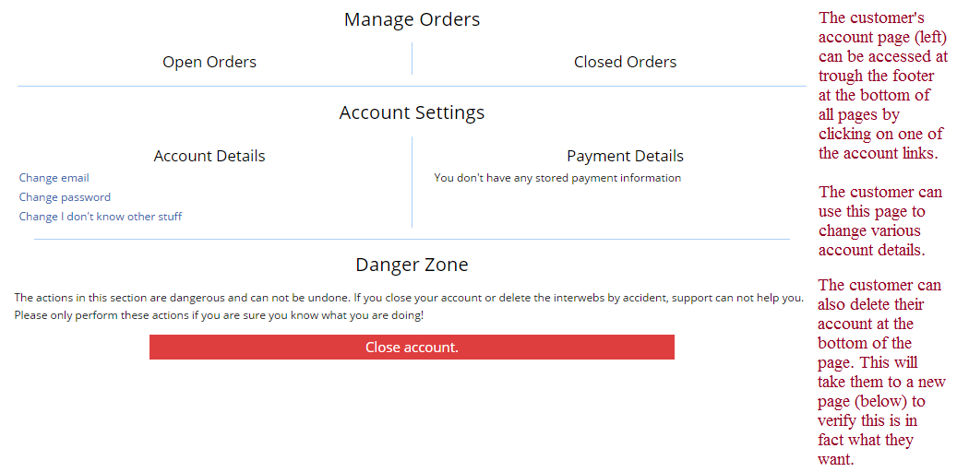
Evaluation
The website as a whole is mostly functional, due to issues outside of the group’s control the site is not as complete or as functional as we would have liked however the main functionality of the program is still there. Everything in the functional specification has been implemented.
For the design we decided to go for a more minimalistic look to ensure that the site was easy to navigate but not boring. The sky blue navigation bar and buttons gives the site a lift to detract from the otherwise mainly functional interface. The logo was designed to incorporate aspects or the Amazon logo and the Spam logo to ensure some entertainment for those visiting the website. Overall the site is not overly cluttered instead focusing on what is important to the user. It also means that the site is still user friendly for those who have some visual impairment.
The website has been designed so that it is viewable on a number of different devices and browsers without hampering the user interface. It works perfectly on Chrome and Mozilla Firefox, however it goes a bit wonky on Internet Explorer and the mobile site needs some work before it’s truly fit for purpose. We have decided to get rid of the mobile site as we do not have the time to make it fit for purpose let alone make it presentable or anything nearing “pretty.”
Parts of the code are easy to maintain. The database is easy to fix and update as it is held in a separate file. The rest of the code would require a good understanding of the languages used and help from the original programmer of the page after that person has reacquainted themselves with the page/code. As is indicated in this paragraph the code is not particularly elegant. It is slightly disjointed and requires a lot more comments. Parts of one page are stored in many different files.
The group has encountered a few problems with this project, mainly stemming from not having the most up to date version when starting work on a new problem. There was one large issue overall when one person committed a version that had a conflict in it and crashed the rest of the code. Other than that, there were only minor problems with formatting or using some discrepancies on how each language wanted a query presented.
Overall the group made a good effort though there is a lot that would have been done differently. Better planning from the beginning and handing out specific tasks to each person so that everyone knew which part of the site they had responsibility for. Had time allowed we would have liked to have added in some extra functionality such as implementing an advanced search feature or a reviews section for each of the products.

Comparison
Having compared our website to Beyond Retro, there are many similarities between the two sites. Both sites have a log in and register feature, a search option and both navigate through a main bar at the top of the page.
There are a few points that Beyond Retro excels beyond ours. When you view the site it informs you that you are using cookies and you can also choose the language that you wish to view the site in. It also tells you how many items there are in your basket and when you add something it opens a pop up to show what is in your basket and your running total. It also offers more details about the products.
However Beyond Retro does not store any payment information so the customer has to enter it or choose a method every time they make a new order. We also offer auto-complete in the search bar where Beyond Retro does not.

